Operating System

Operating system is a system software, it works as an interface between user and hardware.

1. 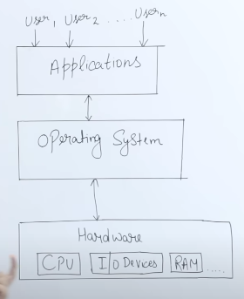If OS wont be there then every time a user wants something he has to write a program to di that task. Example if u want to print something thn u have to give command to the printer by writing a program.
2. Ex - Windows/Macintosh.
3. Primary Goal is to provide Convenience.
4. Throughput means number of tasks done in a unit time. OS provides great throughput (Best is LINUX).

Functionality-

1. Resource Management – Whn multiple user try to access data from a common server it helps in resource management. Basically for how much time or in what amount the requested hardware should be provided to the user so that the server wont be any load in the system.
2. Process management – If u r using multiple software at the same time how to execute all these process at the same time. (CPU Scheduling) Ex- if u wnt to execute a C file, (now it has become a process) so how it will be executed is done by CPU scheduling.
3. Storage Management – Storing in the hard disk.
4. Memory Management – (RAM) - as RAM is limited a task is loaded first in the RAM so for how long it will be loaded in ram and after execution freeing of the RAM is called memory Management.
5. Security – Providing security by authenticating the user. A process P1 cannot access data of process P2.

**Types of OS-**

1. Batch OS - They used Punch Cards Paper Tape or Magnetic Tape Loaded with the Process or Job one wants to do and then give it to a operator in a company. And the operator will convert similar kinds of jobs or process in a Batch (B1, B2). For Example if the operator provides the System or CPU with Job1(Like I/O stuff) of Batch1 then till the time result comes out CPU will be in the Idle condition so other jobs can’t be done. IBM made Fortram or IBSYS709x in 1960s which were the system that used monitors to replace operators.
2. **Multi programmed OS** – Multiple process will be executed at ones in RAM.

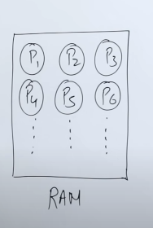

If we give P1 process from RAM to CPU then CPU will execute P1 then P2 will be sent for execution but if in between P1 wants to go for some input output stuff then at tht point CPU will be free so P2 will be provided to CPU. It is called **NON PRE-EMPTIVE**

**This focuses on ki CPU should not have idle time.**

1. **Multitasking / Pre-emptive or Time Sharing** - CPU will give each process a fixed amount of time, in that time frame if the task is executed then well and good otherwise CPU will be move to next process and the previous process will wait for its next turn.

This focuses on Response time ki every process will be given time.

1. **Real Time OS** - Non-Real time OS means the result will be given after a while. But in Real time it gives u result without a delay. (a) Hard – Time is very imp, delay should not be there like missile system. (b) Soft – Some delay can be there.
2. **Distributed** - The system is distributed geographically but are connected through a network.
3. **Clustered** – The system is connected via LAN in local area. All together work like a Server. If one fails other can do its work.
4. **Embedded** – They are made for specific purpose. Ex- Printer.

**Process States in OS** – When u do a process in ur device what are the processes it goes through.

**Primary and Secondary States –**

1. New State - Creating a new process, Ex – Opening chrome.

LTS - Long term schedular, specific processes ko le k aata hai RAM k andar. (This process is called multiprogramming)

1. Ready State– Process is under RAM. (Queue k andar aagya hai)
2. Running State or CPU- Now few Process are Dispatched into running state to the CPU for execution.
3. Terminated – After the execution of the process it is terminated. And the memory address or the resources are deallocated.

If koi priority wala process aagya beech m termination k pehle toh Poorane wale process ko ready state m wos bhej dega from running state and jo priority process hai usko execute krega pehle. Dusra reason kisi process ka wps bhejne from Running state to ready state is **time quantum** which basically means ki specific time k lite process tha us time k hojane pr wo wps chla gya aur dusra process aagya. Agr specified time m hogya terminate toh thk hai ni hua toh wps jaayega.

Aur ye krta hai STS Short Term Schedular (between Ready and Running State).

Agr Running se Terminated hogya directly mtlb multitasking ni hua isko kehte hai Non Pre-emptive. Aur agr wps gya Running se Ready toh Pre-emptive kehlata hai

1. If the process says ki usko I/O related kuch krna hai toh **Wait/Block state** jo ki RAM k andar hi aata hai usm daal deta hai CPU usko. Then jb hojata hai kaam toh Ready state m jata hai then wahan s jata hai running state me.
2. Agr 10 Processes hai jo ki kehti hai unko I/O process hai toh Wait block toh RAM ka hi part toh queue m kitne log ko rkh skta toh processes ko **Suspend Wait (secondary memory)** me bhej deta. Jb I/O ka kaam hojaye tih Wait state m wps aajana.

And this is done by **Medium Term Schedular.**

1. Agr Process 10 hai jinko ready state m bhejna hai and if kooi Priority Process ajata toh kuch processes ko Suspend Ready State m daal dega and space agr wps mil jayega toh wps aajayega ready state me.
2. Agr Suspend State se wps jana chah rah ai apna I/O ka kaam krne k baad but Wait state ki Queue bhari hui hai toh Wahan se wo Ready state m chal jayega directly and agr Ready state bhi bhari hui hai tih wo Suspend Ready state m ruk jayega. Isko kehte hai

**BACKING STORE.**

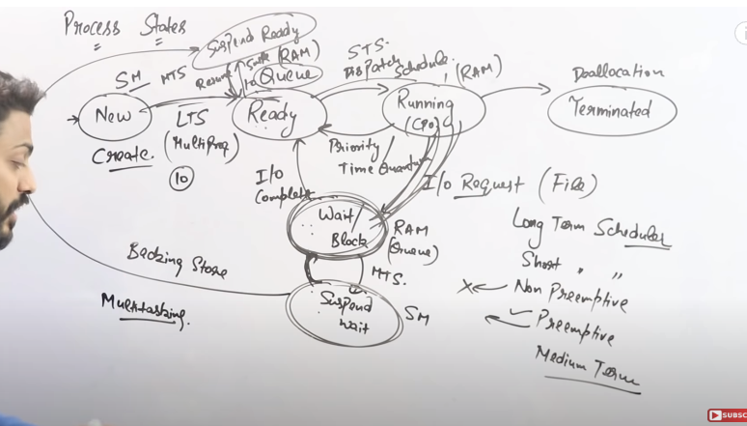

**Linux Command –**

U user

G group

O Other

R read = 4

W Write = 2

X Execute = 1

To multiple commands just add all these

1. To give r w to U G O then add r w = Ch mod 666
2. To give r to U G O then = Ch mod 444

LSeek is used to randomly move start and end pointers.

1234567890

LSeek(n,10, SEEK_CUR) – Move 10 from starting including 1

1234567890a

LSeek(n,5, SEEK_SET) – Set the pointer to value of 5.

1234567890

LSeek(n,5, SEEK_END) – Move 5 places from end

1234567890

**System Calls –**

It’s a programmatic way tht a user can shift from user mode to kernel mode where we can access the functionality of OS. If u want to print 2+3 on monitor so the calculation is done by user mode or the processor but the printing thing on the monitor or by the printer which means ki agr kisi device ko access krna hai toh wo Kernel mode k through hoga.

System call invokes kernel to perform particular task.

1. File related SC - Open(), Read(), Create File etc.

We write c program in any application But when we execute it so during running mode it becomes a process and now it comes under RAM and kernel is also in RAM(Main Memory). So if u want to open a file Process don’t have that privelage so Process will invoke the Kernel and access the particular file.

1. Device Related - accessing any device by using read, write, Ioctl,fcntl.
2. Information related - Processes ya device k related info lena hai ex- get Pid(ID ka pta lagana) , attributes, get system time and data. Basically means metadata(data about the data) pta lagana hai.
3. Process control - Program are saved in secondary memory but when we have to execute it we use process control. Ex- Fork(Makes a child process, Parent and child do their respective process), Load, Execute, Wait, signal, allocate.
4. Communication system - Two processes communicating with each other. Ex- Pipe(), create/delete.

Fork() - If Parent Process is busy then child process is created to perform a particular task. Which will be clone of Parent process and will have a different ID.

It gives 3 value mostly 2 – 0(Child Process), 1(Parent Process), -1(if child process was not created but mostly its not counted).

Child and Parent Parellel execute hote hai

Main(){

Printf(“Hello”)

} **Out- Hello will be printed ones.**

Main(){

Fork();

Printf(”Hello”);

}

P (Fork) **Out- Hello will be printed Twice.**

P(Parent Itself) (Hello)

C1(Child) (Hello)

P (Fork) **Out- Hello will be printed Four.**

P(Parent Itself) (Hello)

C1(Child) (Hello) P(Parent Itself) (Hello)

C1(Child Itself) (Hello) C3(Child) (Hello)

C2(Child) (Hello)

**3 Child and 1 Parent**

Total Number of times Execution (Here Printing Hello) will be there is 2^n

And total number of child process will be there is 2^n-1.

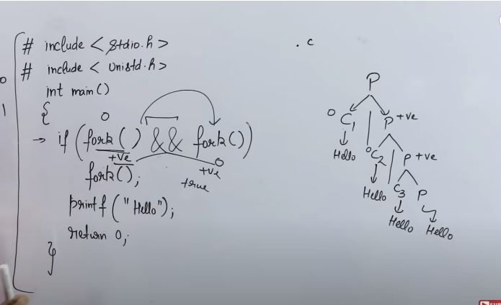

The C Program is saved as .c so it can be called as a Parent process.

If(Fork() && Fork())

As 1st Fork comes the parent process will create a child

1st case – c1= **0 && anything is 0** so **it wont go inside the if statement** and Hello will be printed.

2nd - p=+1 so it goes for the next fork and **c2 will be created**. If and is done with **c2=0 then Hello** will be **printed** and if it is done with p=+1 then it goes **inside the if statement** and again a fork happens and **c3 is created** and thus bcoz of the **3rd child Hello is printed** and bcoz of **P itself hello** is printed.

**User Mode and Kernal Mode**

Using any application by the user comes under User Mode, But all the functionality of the OS comes under Kernal Mode. The processor switches between User and Kernel Mode.

Using a Text editor(reading r writing in it) comes under user mode but accessing any file for Ex- which is stored in hard disk comes under kernal mode.

**Read Instruction to access the file in the Hard Drive**

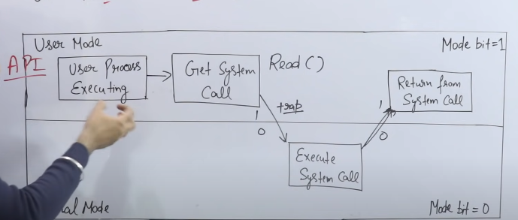

**This is** **Hard Drive**

**Interrupt or trap to switch from Mode bit =1(user) to mode bit = 0(Kernal)**

If in c program u do 2+3 it comes under User mode but to print it (printf) u have to access the monitor which comes under Kernal Mode.

**We Work under User Mode and OS work under Comes under Kernal Mode and there is switching going on in between.**

**Multitasking Environment** create krne ke tareeke.

1. Processs – use Clone or Child process by doing system call(Fork).
2. Thread - more threads a created and data/code is shared but stacks and registers are same User level p create hota hai ye.

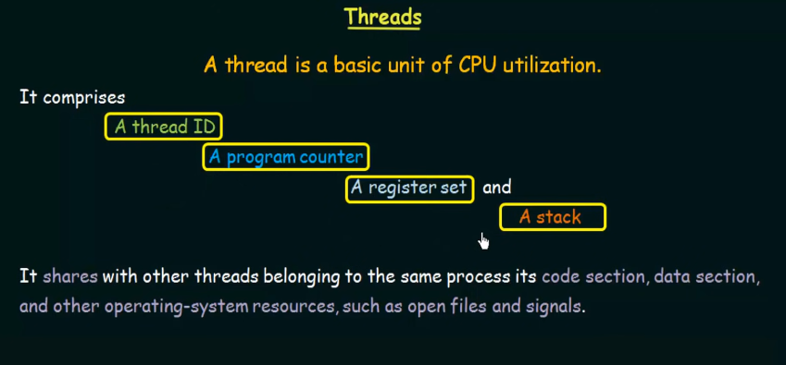

Context switching ka mtlb hota hai ki time quantum k liye chlta hhai ek process then wo rukta hai then dusra process ya child abhi process hoga jb tk ruka hai pehla wala uska data kahin to store hoga, isliye context switching slow hoti hai Process me as compared or thread.

Blocking a process mtlb ki agr kisi process ko I/O ka kaam hai usko block state m daal k wo dusra jo child process hai wo block ni hoga jb hojayega pehle wale ka kaaam wo ready state m wps ajayega. lekin Thread me poora block hojayega

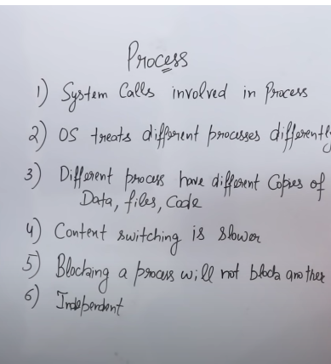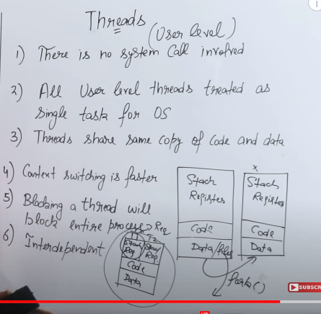

Thread Process

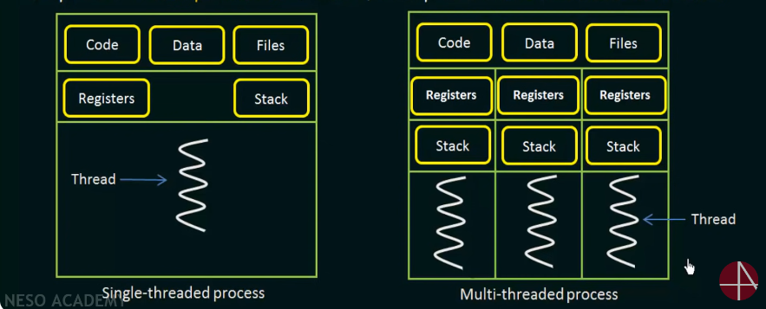

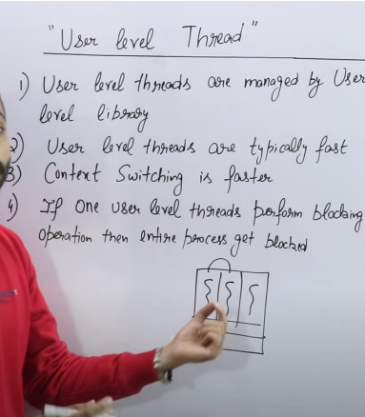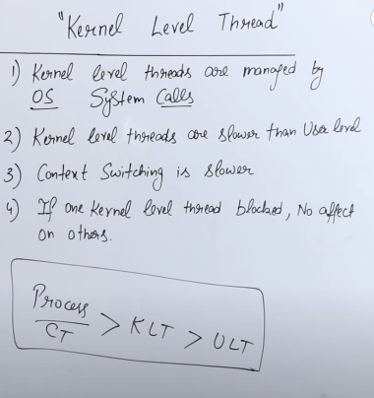

Process Scheduling – Way of selecting a process from Ready Queue(RAM) and send it to Running Queue(CPU).

Pre-emptive – If Process is sent back from Running Queue or CPU to Ready Queue to execute other processes. The reason can be time quantum or high priority process can come in the list, This increases the response time as the CPU will be able to give time to all the process in a short interval.

Ex - SRTF, LRTF, Round Robin, Priority Based

Non Pre-emptive – Opposite of the above. Ex- FCFS, SJF, LJF, HRRN, Multilevel Queue, Priority Based

CPU Bound – Amount of time CPU will take to execute which is told prior only.

I//O Bound - CPU asked if u wnt to perform any I/O thing go and come back so tht time taken by I/O operation is called Waiting Time or I/O Bound.

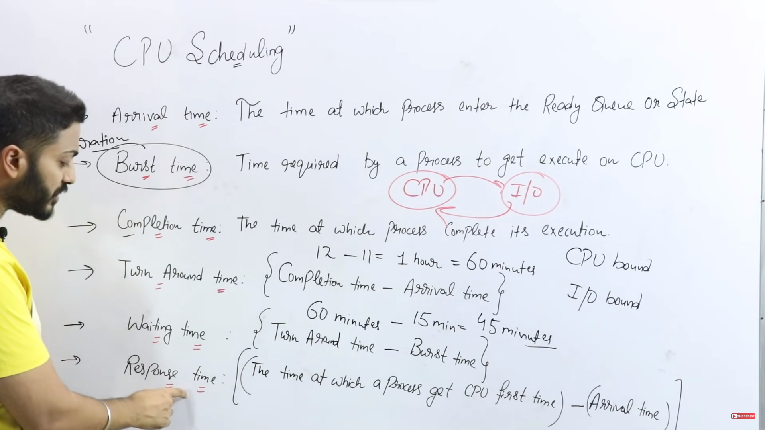

Non- Pre-emptive – Full Duration tk chalega ye.

(a)FCFS – First Come First Serve – **Non pre-emptive me Response time and Waiting Time Same hoga.**

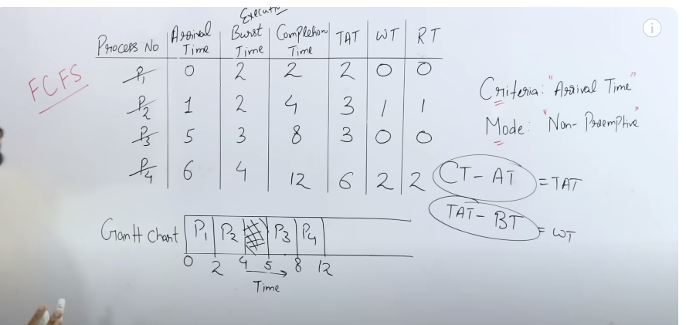

Average turn Around time = TAT/n = 14/4

Average Waiting Time = WT/n= ¾

P1 aaya 0 pe, Gantt Chart m 0 p daale usko 2 sec liya aur execute hua. P2 1 pe aana tha but ruka hua tha p1 k complete hone k liye then 2sec p usko mila CPU fir wo 2 sec lega execute hone p toh total 4 sec hoga. Then p3 aana hai 5sec p lekin abhi 4 sec hue hai so 1 sec wait krega then 5sec p CPU milega usko and 3sec lega wo toh 8sec tk jayega wo thn p4 aa cbuka tha 6sec p lekin wait kiya wo p3 ka then 8sec p mila usko CPU nd wo 4 sec lega to execute so total lagega 12 sec.

So the time at which all the time got executed was 12secs.

**(b) SJF – Shorted Job First.** – jiska Burst time sbse kum hoga.

0 secs at grant chart p koi aaya ni hoga toh 1 sec tk CPU khaali rahega then 1 sec p aaya p1 and p3 toh burst time check kiye tb p3 ko select kiya wo2 secs lega toh jayega 3 secs then at 3secs p1 and p3 ready honge but p1 lega 3 secs isliye p1 jayyega 6secs tk tb tk p2 and p4 ready honge ready state me thm dono ka burst time same hai tb arrival time check kro tb p2 pehle aaya isliye usko select krenge lekin agr **dono ka** **arrival time bhi same hota toh ID check krte p2<p4 islitye tb bhi P2 hi use hota pehle.**

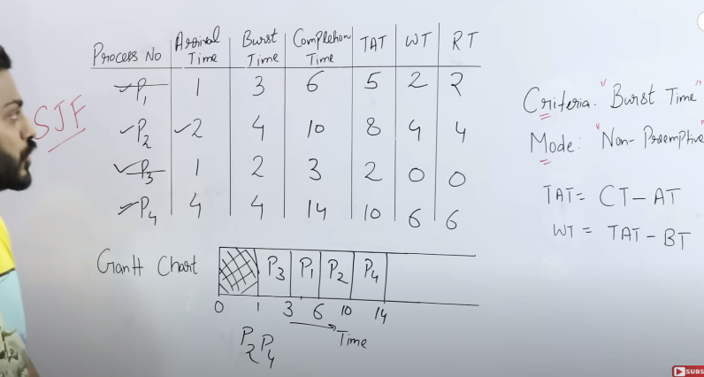

**Pre-emptive**

1. **Shortest Remaining Time First** or **SJF** with Pre-emption

Pehle ye check kro ki kaun aaya hai pehle Burst time tb check krna jb same hho Arrival time.

P1 aaya 0 p, 1 sec bs chalao uska burst time hua ab 4 sec thn check kiye ki 1 sec p toh p2 bhi aagya hain d usko burst time(3) kum hai p1(4 now) se then p1 ayega ready queue me nd p2 ko milega CPU. Then usko bhi ek sec chalaye nd ab uska burst time bacha 2. Then 2 sec p1 p2 p3 ka check kro tb p2 ka hi kum hai fir 1 sec tk chalo ab 1sec bacha uska fir at 3rd sec p1 p2 p3 check kiye tb p2 fir chala thn its over at 4th sec. ab 4secs p p1 p2 p4 aagya and p4 ka 1sec hai burst time tb 1sec chalaye tb p4 khtm ab 5th sec p p1 and p3 check kiye tb dono ka same hai burst time 4, tb arrival time check kiye and p1 chala 1 sec tk thn check kiya fir thn again nd again coz p1 hi chota hai toh wo khtm hote tk chalega thn p3 shuru hoga udhr se and poora chalega.

Completion time hai jb last baar p1 aaya tht is 9secs. Aise hi baaki ka.

Response time pre-emptive m imp hai.

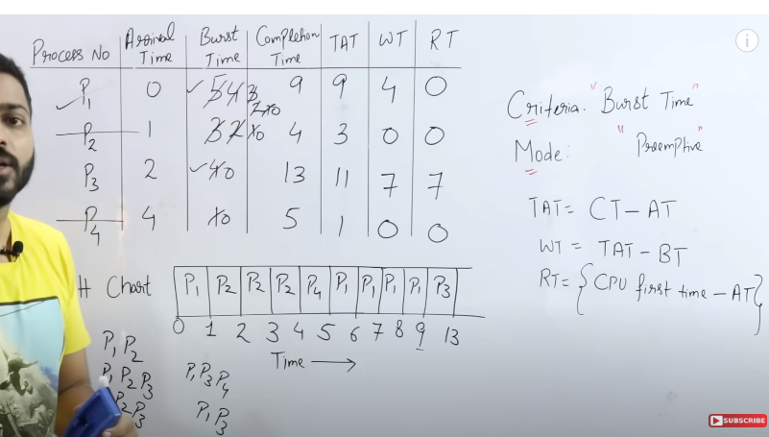

Reponse time is kb aaya process Left side check krna Grant chart p

Response time for p3 = CPU first time (9) - Arrival time (2) = 7

1. **Round Robin – Pre-emptive**

Use 2 queues.

0 Time p P1 aaya then usko daalo Ready queue se Running Queue tk ab alag se

**Time quantum diya gya hai 2secs** toh ab P1 chal 2 secs tk then Burst time hgya 3 secs ab 2time pr p1 p2 p3 teeno ready hai toh ab baaki 2 ko ready queue m daalo and 2 time k baad p1 ko wps daalo ready queue m p2 and p3 k baad lekin (Context Switching – Running process k **Running Process Block** mtlb uss process ki saari info jism hoti hai usko save kro taaki baad m usko wps se resume kr ske) and add P2 to it 2 time chala **Pehle Check kro ki koi aur ready hai kya usko daalo ready queue m thn check kro jo current hai running queue m wo bacha hai kya agr bacha hai toh daalo usko running queue m.** thn p3 aayega jo ki 2 time k liye hi chalega pr P3 ab khtm hogya hai thn p1 aayega running queue m then p1 ka 1 bachega burst time usko wps daalo ready queue. And p4 1 sec chala utna hi tha uska **and ideal time ni chalega ye** and p2 neeche aaya.

Now for finding Completion time and all check Running Queue

**Kitni Baar hui Context Switching – last and first chodd k saare hain toh total 6 here**

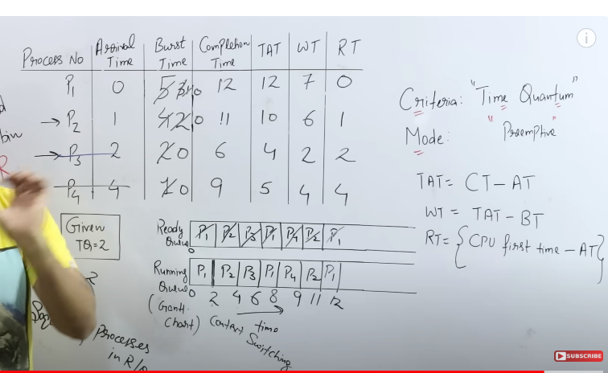

**Priority Scheduling With Pre-emption Mode**

Higher the number higher the priority 40(More Priority) > 10

1 time unit tk chalana hai p1 ko coz aarival time pehle hai uska then check krna hai koi dusra aaya hai ya ni p1 and p2 dono aagya then p2=20 tb p2 chalega

After 2 time p1 p2 p3 queue m hain toh p2 jayega wps ready queue m and p3 run hoga thn p3 wps chalega coz p4 4th time me aayega,

Ab p3 khtm hai ab p1 p2 p4 aayenge thn p4 has more priority aayega wo ek baar chalega thn p4 khtm ab p2 ki priority zyada thi toh wo chalega

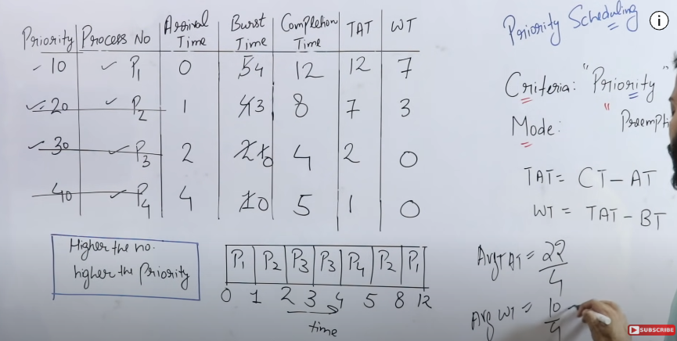

**Same priority hui toh Arrival time dekhna wo bhi same hogi toh ID dekh lena**

**Priority Based Question (Pre-emptive)**

Here Lowest the number highest the priority.

0 pe p1 aaya 1 unit tk chalaye(aur iska CPU diya bhi tb tk hi hai)

1 to 2 idle hai

2-3 aaya p2 priority 3 es hui 2

3 p aaye p3 and p4 nd p1 already hai

3-4 chala p3(1 priority hai iski)

4-5 chla p3 aur khtm hua

5-6 chlega p2 coz priority 3 hai uski

Ab,

1 se shuru hua tha p1 and wo I/O kr k 5unit time ka 6th time m wps aagya hai

Ab p2 and p1 m p1 ki priority zyada hai (2) toh p1 chalega

6-8 chla p1 then 8 p p3 ka I/O khtm hua

P3 8-9 chlega aur execute hoga then p1 9-10 chalega aur khtm hoga

P2 chala 10-11 ek baar thn I/O k liye gya

P4 11-13 chla and IO start kiya

13-14 Idle rahega

Thn 14-15 chlega P2

Then 15-17 idle rahega CPU

17-18 chlega p4

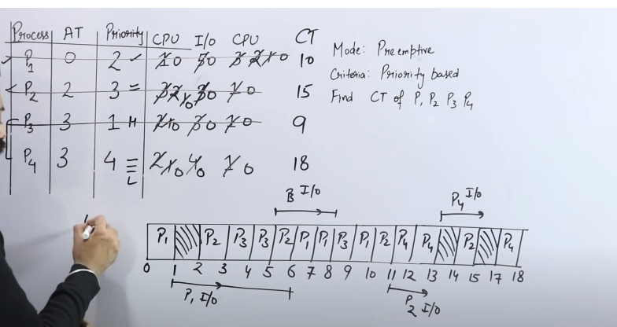

Ratio of Idleness = 4/18

Ratio of Usage = 14/18

**Multilevel Queue Scheduling** - Different Process will have different Ready Queue.

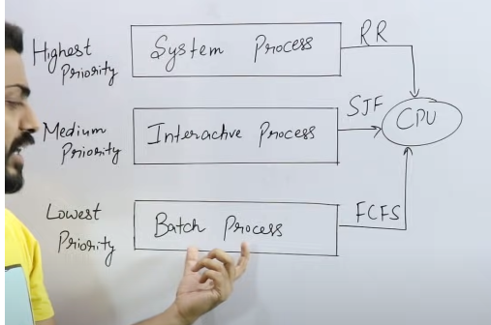Ex – Interrupt (Round Robin is used)

Ex- using App like VLC

(SJF)

Ex – Multiple App used in BG (FCFS)

Adv – We r categorising diff process

Dis - Starvation Problem ki System Process yada aagye toh baaki execute kb honge.

The Above Problem is solved by – **MultiLevel Feedback Queue**

P1 ko kuch time quantum k liye execute kiye thn usko upgrade kr diye **(Feedback diye usko)** from lowest priority to highest priority, ab jo lowest priority ki jagah thi wo khali hogyi wo another process.

Age koi High Priority wala aajata ha alag se toh wo normally solve hoga.

P1 = 19 unit time lega solve hone ko(lowest priority) 2time quantum k liye chla.

Next queue m wo 4 time quantum k liye chla.

Next queue m wo chla 8 time quantum

Next queue m wo FCFS ya kisi se bhi se wo chalega aur execution complete krega.

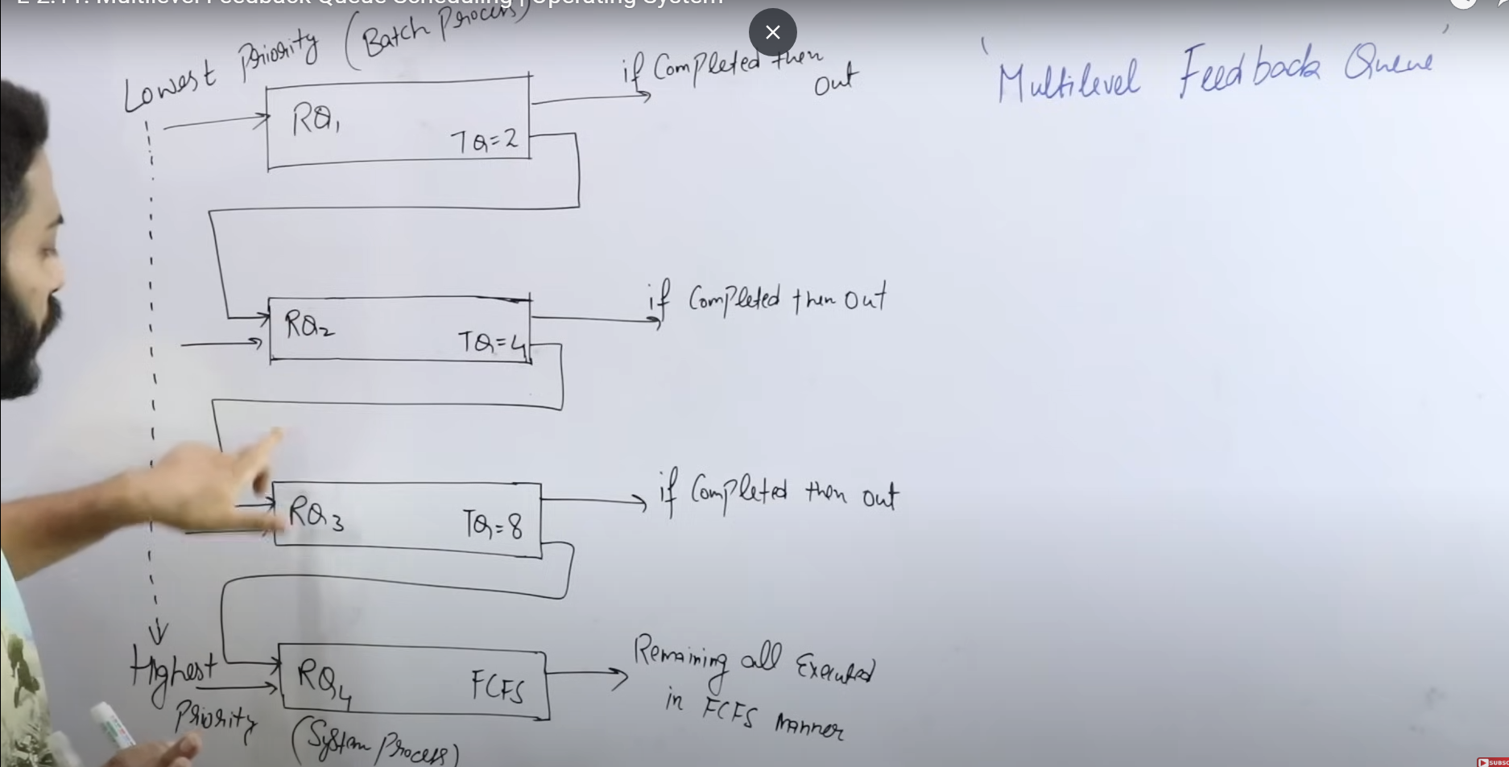

**Process Synchronization –**

1. Serial Process - Process at a time.
2. Parallel - Multiple Process Running at the same time.
3. Independent Process – Process that are independent.
4. Co-operative Process - They might be sharing the same memory or buffer or code or same Resources (Devices). So, the execution or working of one depends on the other. A cooperating process can be affected by other processes executing in the system. Also it can affect other processes executing in the system. A process shares data with other processes, such a process is known as a cooperating process.
5. When several processes access the same data concurrently and the outcome of the execution depends on the particular order in which access takes place is called **race condition. – If p1 execute kr rah ai already Critical section ko and usi waqt p2 bhi kr rah ai execute toh use kehte hai race condition.**
6. If a process is executing in its critical section, then no other processes can be executed in their critical section. This condition is called Mutual Exclusion. Critical section of the process is shared between multiple processes. If this section is executed by more than one or all of them concurrently then the outcome of this is not as per desired outcome. For this reason the critical section of the process should not be executed concurrently.

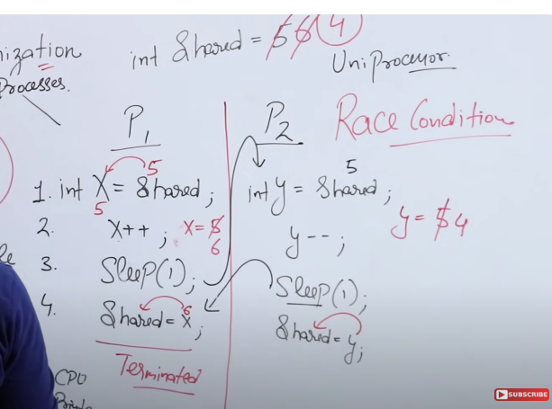

Answer dono case m galat aara hai coz the **processes are not synchronised.**

Producer Consumer Problem –

Printer-Spooler Problem – Spooler is a program Multiple users dete hai documents and spooler ek ek kr k sequentially bhejta hai printer ko for printing.

Case 1

P1 bhej ra Doc1 to Spooler Directory

Initially IN=0, R1 me uska address store hogya ab,

Store hogya 0th place me Doc1

R1 increase hua and IN=1 hua.

Thn Doc1 will be printed

Case 2 - Agr already Doc1,2,3 present hai thn Doc4 and 5 cooperative process hai and dono m se ab kaun aayega tb dikkat hojayega.

**Critical Section -** 2 programs ya process k andar agr kuch common hai like variable or data toh toh usko critical section m rkhte hain.

2 Programs hai agr unko critical section ko access krna hai, toh ek entry section banana hoga ki agr p1 clear kr de ra toh ab wo use kr skta critical section tb tk p2 use ni kr skta critical sec. Critical Sec se wo Exit Sec jayega and Execute krega Exit sec ko.

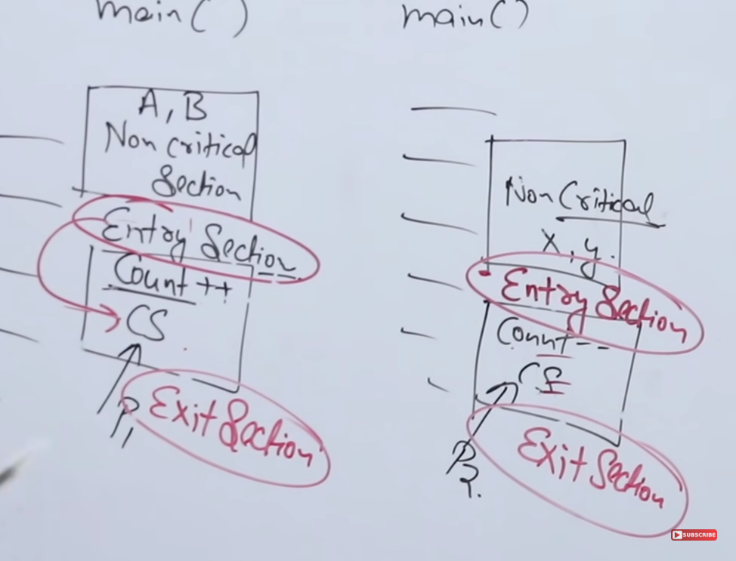

Methods for Process Sync –

It should fulfil 4 conditions –

1. **Mutual Exclusion –** Agr P1 already andar hai Critical sec k toh p2 ni aaskta and vice-versa.
2. **Progress –** P1 aana chahta hai CS me but P2 k entry sec m kuch aisa likha hai ki wo P1 ko block kr ra hai toh progress ni hoga. So Avoid such thing and **there must be Progress.**
3. **Bounded Wait –** P1 is used CS and got out thn P1 again used it and came back and it is going on for infinite and P2 is not able to use it. So There must be a limit till which P1 can use CS(1 or n times its ohk but not for infinite time).
4. **No assumption related to H/W and speed –** The solution should work in all the devices.

**Lock Variable in OS –**

1. It works in User Mode.
2. Multi process Sol.
3. **No Mutual Exclusion Guarantee.**

Case 1 -

1. Initially Lock = 0(Vacant)
2. Then P1 Enters in the Entry Sec and Lock now = 1 then its in the Critical Sec
3. If P2 Tries to enter CS, rn Lock=1 so it is now in an Infinite Loop and will be there till the time Lock=0.
4. P1 Enters the Exit Sec and now Lock =0 and P2 can Enter now.

Case 2 –

1. P1 ka Line 1 Hua Execute then wo pre-empt hogya(I/O k liye gya).
2. P2 aaya usne Line 1-3, Critical Sec m aagya execute ki then pre-empt hogya ab wo (Lock=1).
3. P1 Line 2 se wps aaya ab already Lock=1 lekin usne firse 1 hi kr diya and Critical Sec m gya.
4. P1 and P2 dono Critical Sec m **hai there is no Mutual Exclusion.**

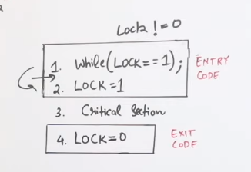

To get Mutual Exclusion We use –

**Test and Set Instruction –**

There is Pre-emption between Line 1 and 2 then to solve tht we combined it.

1. While loop m gya then ek function hai Test_and_Run naam ka.

2. target pointer address hold kr ra lock variable ka jo ki initially false calue hold kr ra then

3. Boolean r = *target (r me target ki value i.e. false)

4. *target =True (Target ki value ab true kr diye)

5. return r (r ki value return kr diye)

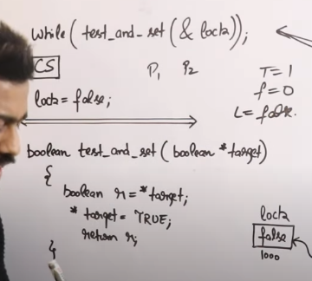

P1 gya loop me and lock= false tha ab wo true hogya and r =false hogya(test and set dono hogya)

Return hua false and P1 gya CS me

P2 jaayega bola ab neeche aaya lock=true tha aur ab bhi true hi hai then r=true hogya lekin. And return hua true aur ab P2 infinite loop m fass gya.

**Turn Variable (Strict Alteration)**

1. 2 Process Solution.
2. Run in User Mode.

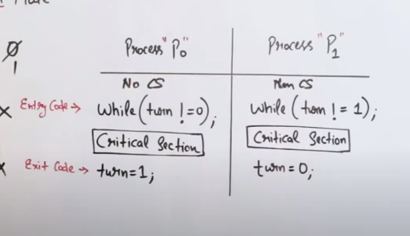

While k baad next line hai CS andar ni hai While k

Turn = 0 loge toh p0 pehle jayega and turn =1 hua toh P1.

1. Mutual Exclusion is there
2. progress Ni hai Lekin
3. Bounded Wait Hai
4. Can Run in any Device

**Semaphore** is an integer variable which is used in mutual excusive manner by various Concurrent cooperative processes in order to achieve synchronisation.

2 Types of Semaphores –

1. **Counting (-Infinity to +Infinity)**
2. **Binary (0,1)**

For Entry section use – P(), Wait, Down functions.

For Exit Sec use = V(), Up, Signal, Post

Counting Semaphore -

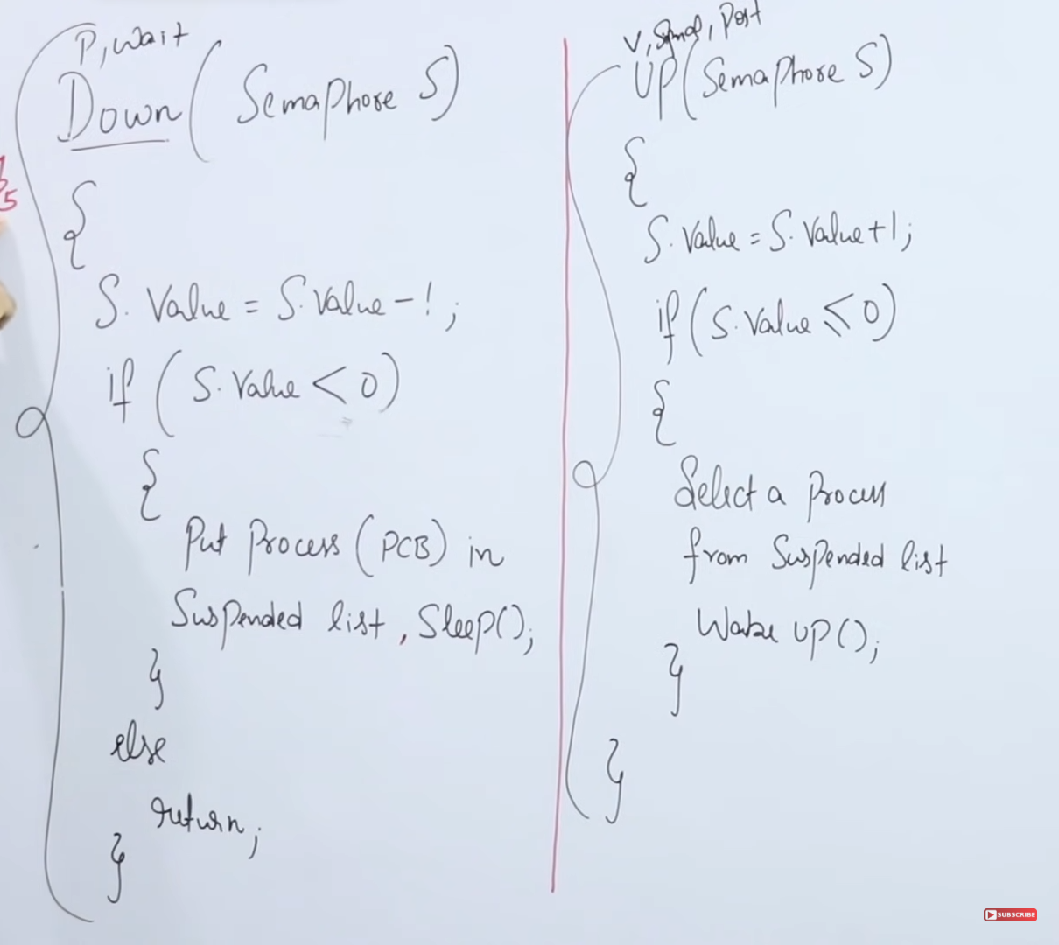

Ek hi Andar Jayega Critical Sec k yahan bs hum Example dekh re.

For Ex- s= 2, P1 aata hai S.value-1 hoti hai so S=1 now,

Ab P1 Andar hai CS, then P2 aata hai S.value-1 joti hai S=0 now

Ab P2 andar hai CS ke

Ab P3 aata hai S.value -1 hai false hua statement amdar gya IF() me and Suspend hogya Process.

Same for P4 also S=-2

Now, Exit Sec

P1 CS use kr k bahar aaya and S=-1 now and if statement me gya wo and ek suspended process P3 ko Ready queue m daal diya for Entering the Entry Sec.

Then P2 gya and S=0 and p4 is in Ready Queue.

Ab S=0 hai toh ab P3 ya P4 aaskte similarly

**S=2 toh 2 process aaskte CS me and Suspended Sec m koi ni hai**

**S=0 toh koi aur process ni aaskta ab CS m abd SS khali hai**

**S=-2 toh bhi CS m koi aa ni skta and SS me 2 Processes hain**

Binary Semaphores –

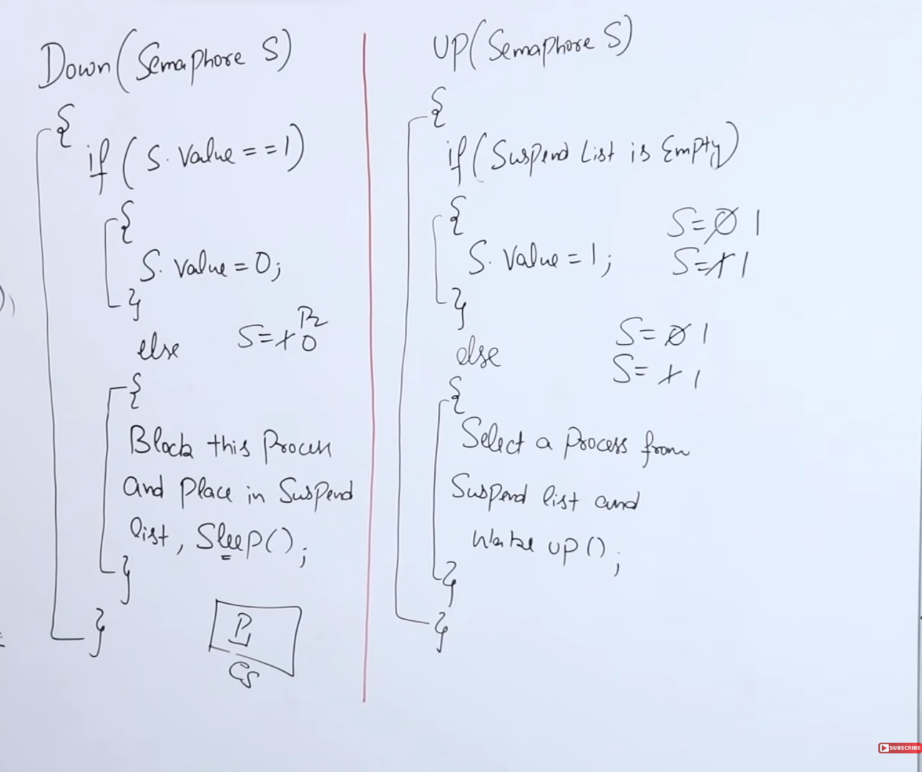

S = 1 hai tb Down S hai

P1 aata hai and S=0 hoga ab aur CS m jayega

Down S hai

P2 aata hai S=0 hai, Suspend hojayega Process.

UP S

Pehle Check krega Suspended List Empty hai ya ni

P2 hai SS me toh wo Ready Queue me jayega.

P1 wps se check krega thn S=1 hoga aur P1 CS ka bahar (V ya up rokte nahi hai kisi ko andar aane se CS k)

Then P2 enter kr skta hai agr down S hai tb

A semaphore is a shared integer variable that cannot drop below zero. In binary semaphore, if the value of the semaphore variable is zero that means there is a process that uses a critical resource and no other process can access the same critical resource until it is released. In Counting semaphore, if the value of the semaphore variable is zero that means there is no resource available.

When a high priority task is indirectly pre-empted by a medium priority task effectively inverting the relative priority of the two tasks, the scenario is called priority inversion.

Cascading termination refers to termination of all child processes if the parent process terminates.

**Deadlock** - If two or more process are waiting on happening of some event, which never happens, then we say these processes are involved in deadlock then the state is called Deadlock.

For an effective operating system deadlock is checked for every time a resource request is made at fixed time interval.

Condition for Deadlock –

1. Mutual Exclusion
2. No Pre-emption
3. Hold & Wait If P1 is holding R1 and P2 is holding R2 then if P1 wants R2, P2 should not leave L2. Every Process should Hold there data and wait with it.
4. Circular Wait – There Should be a circular Loop.

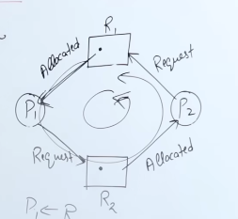P1 P2 P3

R1 R2 R3

P1 is pointing to R1 and Waiting for R2

P2 is pointing to R2 and Waiting for R3

P3 is pointing to R3 and Waiting for R1

It’s Circular

**Agr Single instance hai harr ek Resource(Data) ka and Cyclic hai toh pakka deadlock hoga.**

Resource Allocation Graph – It’s a way to represent the state of a system.

Kis Process ko kaun sa Resource assign hua hai.

Single Instances

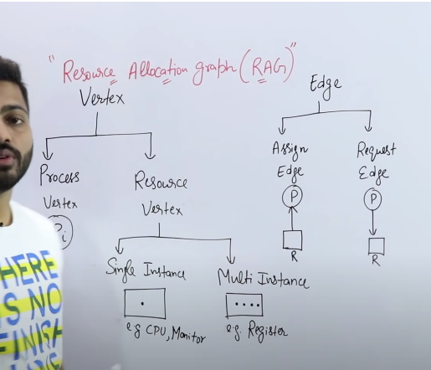

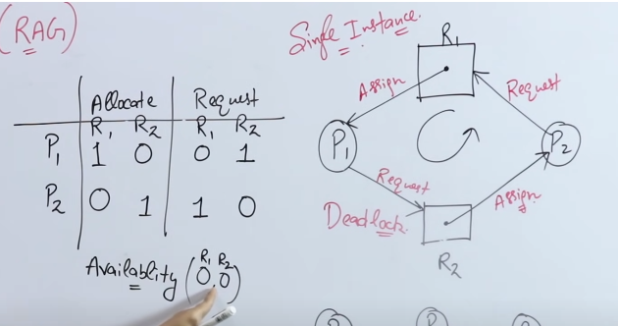

P1 k pass hai R1 and Usko chahiye R2

P2 k pass hai R2 and Usko chahiye R1

R1 and R2 ke sirf ek hi instances hai Toh availability dono ki 0 hai

**Deadlock hogya idhr.**

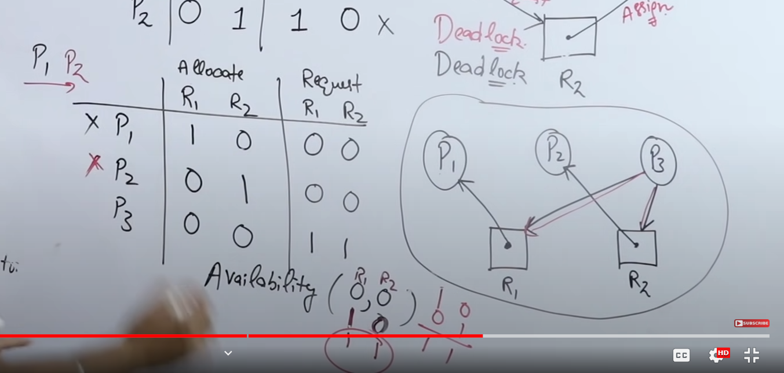

P1 ko chahiye R1

P2 ko chahiye R2

P3 Request kiya hai R1 and R2 ko

P1 and P2 Terminate hua

R1 and R2 ab Available hogye

P3 terminate hua.

Single instance and Circular Wait = Deadlock always

Multi Instance and Circular Wait = Deadlock May and May Not be there

Multi Instances – Mtlb ek Resourc Multiple ko assigned hai

P1 k pass hai R1, Wants R2

P2 k pass hai R2, Wants R1

P3 k pass hai R2

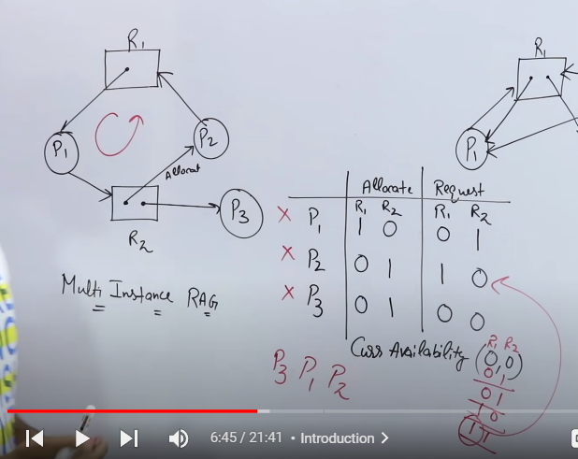

P3 Execute hua.

Availability R1 R2

Initially 0 0

P3 Executes 0 1

P1 has R1 wants R2, R2 is available

P1 Executes 1 1

P2 Executes

Various Methods to Handle Deadlocks

1. Deadlock Ignorance – Ostrich Method – Ignore kro ki aisa kuch hau.
2. Deadlock Prevention – Deadlock ki hone ki probability hi khtm kr do.
3. Deadlock Avoidance – Banker’s Algorithm
4. Deadlock Detection and Recovery.

**Banker’s Algo is used for Deadlock Avoidance and Detection**

Agr ek bhi terminate ni ho paaye toh Deadlock hojayega.

Process | Allocation | Max Need | Available | Remaining Need

A B C A B C A B C (Max- Alloc)

P1 0 1 0 7 5 3 3 3 2 7 4 3

P2 2 0 0 3 2 2 5 3 2 1 2 2

P3 3 0 2 9 0 2 7 4 3 6 0 0

P4 2 1 1 4 2 2 2 1 1

P5 0 0 2 5 3 3 5 3 1

P1 ko Chahiye 7 4 3 Utne hai ni

P2 ko chahiye 1 2 2 hai utne P2 execute hua usne A me 2 le rkhe the wo Free hue ab toh ab AVAILABE HAI 7 4 3 then goes on.

Execution Sequence = P2->P4->P5->P1->P3

**Ism Resource Khojna hai**

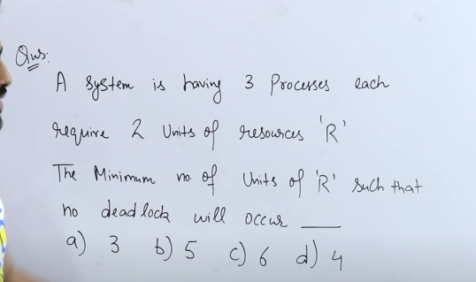

Answer is 4

Agr R=4 hai toh hi aisa hoga ki Deadlock aayega ni

R=3 hua toh ek case m aayega deadlock

**Best tareeka hai answer nikalne ka ki agr minimum pooche toh**

Jitna requirement hai tb for Ex=2 hai aur 3 Process hai toh sb ko ek ek resource de aur fir ek resource aur add kr de

P1 P2 P3

1 1 1

1

P1 Execute hua thn P2 k pass ek gya aur P3 k pass ek gya and dono execute hogye

Max Pooche agr ki kitne **max chahiye Lekin deadlock aaskta** hai toh jitna maange hai toh ek ek de de sbko aur deadlock aajayega

Here the answer is 3

P1 P2 P3

3 4 5 = Required

2 3 4 = Allocate kr diye khudse (Required - 1)

2+3+4 =9+1 =10 ab deadlock ni hoga

Toh min chahiye 10

Max Pooche agr ki kitne **max chahiye Lekin deadlock aaskta** hai toh jitna maange hai toh ek ek de de sbko aur deadlock aajayega

Here the answer is 9

**Ism Demand Khojna hai**

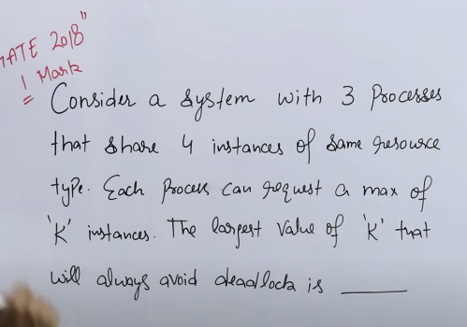

**Abhi Max Value batani hai jism Deadlock nahi aayega –**

N processes and R Resources and D’s are the Demands

**Formula Method**

**Sol –** Find Max Resources but still Deadlock

**Condition with no deadlock = Resources + Process> Demand**

4+3 >3*2

7>6, **k =2 k liye ni hoga deadlock**

**Hit and Trial Now,**

P1 P2 P3 Take k=1

R R R, Yes there wont be a deadlock

Take k =2

R R R

R P1 Execute hoga thn dono R allot honge P2 P3 ko and wo Execute honge.

Take k = 3

Ek case aisa aayega jism Deadlock ajayega

**So the Answer is 2 Here.**

Q. 4P hain aur 4R hai D=?

4+4>4*1

**K=1**

4+4>4*2

8>8 **Wrong Answer**

**Memory Management –** Method to manage all the Memory Resources

**Degree of Multiprogramming** – Zyada se Programs or Processes ko Secondary memory se RAM k andar laao Taaki CPU Execute kr ske usko Kyunki jita zyada Degree of Programs aayenge utna zyada CPU utilization hoga

Agr Ek hi Program aata hai CPU me aur beech m hi wo I/O k liye chla jata hai toh CPU tb khaali baitha hoga aur Efficiency kum hogi uski isliye Multiple programs ko le k aate hai RAM m.

If u increase the RAM toh efficiency increase hoti hai.

Memory Management Techniques –

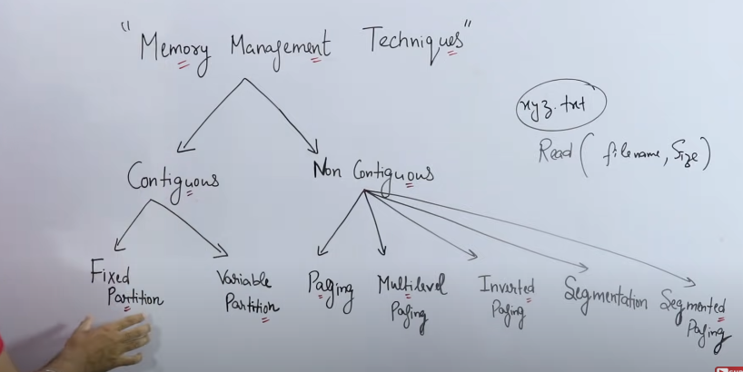

|  |
| --- |
| OS (Address)  (0) |
| P1 (20) |
| P2 (40) |
| P3 (60) |

**Contiguous –** Giving Continuous Allocations. Processes are Kept in Continuos Address Blocks. System On hote hi sbse pehle OS aajata hai top p.

Static Partition - Memory fixed number of slots m divide hojati hai size of the slots me vary it can be fixed.

Dynamic Partition - mtlb jitna process ki size hogi utne size usko allot kr denge.

Contiguous m ek process hai agr toh usko poora dalna hoga aadha adha ni kr skte and Process ki size choti honi chahiye from the Slot in the RAM.

**Static Partition -**

Limitations –

1. Agr 2MB ka Process jata hai 4MB k slot me toh 2MB ka space waste jayega isko lehte hai **Internal Fregmentation.**
2. **Degree of Multiprogramming** less hai kyunki space fixed hai toh aur zyada nil aa skte.
3. **Limit in Process Size** - Mtlb size hai slots ka toh 2Mb,4Mb,8MB uss se bda size ka aa ni skta ab Process.
4. **External Fragmentation** – Maan lo 2 hi slots hain, ek 4MB k Slot m 2MB ka Process hai 2MB bacha hua hai aur ek aur slot hai jism bhi same situation hai ab agr aur ek aur Process aagya, 4MB ka jagah bachi hui hai total 4MB apne pass 2-2 MB kr k lekin, ni rkh skte udhr coz ek hi Process reh skta ek Slot m

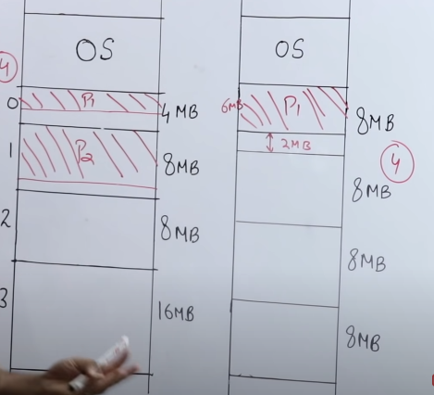

**Contiguous m Continuous memory location m daalte hai Processes ko and koi bhi process ek hi jagah rahega parts m ni reh skta.**

**Variable or Dynamic Partitioning –**

**Positives -**

Run time p Slots banenge RAM m. 2MB ka Process aya toh 2MB ka Slot bna, toh Internal Fragmentation ni hoga, then Run time me bnn ra toh ab there wont be any limitation on the number of process (No limit to Degree of multiprogramming). Process ki size bhi kuch bhi hoskti

**Limitations**- External Fragmentation hoga kyunki Aggr 2 jagah mila k 8MB khali hai aur ek 8MB ka process aara hai toh wo usk andar ni aaskta kyunki contiguous Allocation hai. Ek Process poora ek jagah p rahega and next process continuous memory location m jayega.

It is complex bcoz Allocation/Delocation m dikkat hoga ki koi Process aara hai usi waqt RAM m space banana hai and then Jb jaa rah ai tb hole bna ra hai usko ab uss space ko deallocate bhi krna hoga.

**Contiguous hai ye- Mtlb Process store continuous Memory Location me hote hai.**

First-Fit – Allocate krta hai First hole m hi jo ki big enough hai. Fast hai and Simple hai.

Next-Fit – Jo bhi last Hole bhra hai wahan ek pointer rkh dega aur udhr se fir search lrna shuru krega hole tht is big enough (Kinda like First-Fit). Better hai First-Fit se kyunki shuru s search ni krna pdta isko, pointer ki help le leta hai.

Best-Fit - Search Krega Poora and Jism Least Space bachega wo select kr dega. Internal Fragmentation kum hoga kyunki 15k search kr k 20k wale ko chunega naa ki 25k waale ko even if 25k pehle aaya hai. Slow hai.

Worst-Fit – Choose krega biggest Space ko. 15k agr 100k ki jagah m aajata hai toh 85k bachega usm baaki koi aur daal skte hai. Slow hai

Kata hua hai ji niagram m wo Occupied hai aur blank waale holes hai.

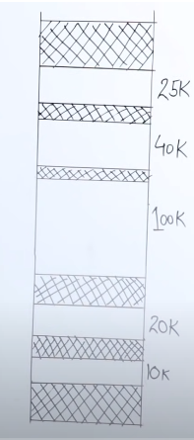

|  |
| --- |
| OS (Address)  (0) |
| P1 (20) |
|  |
| P2 (100) |

**Non-Contiguous** – Processes can be kept in different Locations.

Can divide a 6KB Process into multiple places. Run time m develop hote hain Allocate and Deallocate hote hain RAM m slots and Run time m hi create hote hai holes.

Process ko already divide kr do secondary memory me and harr ek partition ko PAGING kehte hain and RAM ko bhi divide kr do into frames.

**And Size of the Page = Size of the frames**

External Fragmentation Remove hogyi hai Completely.

Non-Contiguous can behave like a contiguous.

**Paging means Processes ko Pages m divide kr skte hai RAM k frames k size me.**

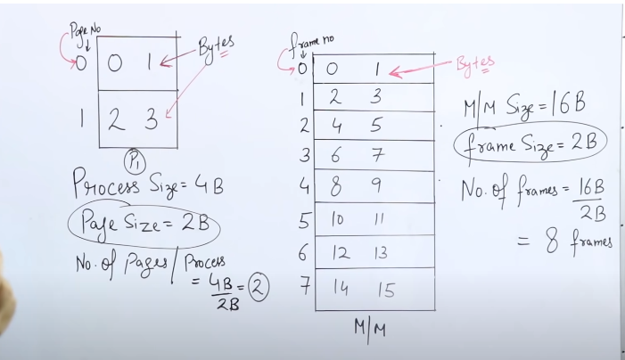

Memory Management Unit – Converts Address given by the CPU to Absolute Address, It uses a Page Table. Every Process has it’s own Page Table. Number of Entries in a Page Table = No. of pages in the Process and Page number holds Frame number of the RAM in which the Processes Byte is kept.

CPU always works on Logical Address. Logical Address is made up of 2 things (a) Page Number (b) Page Offset (Address).

Page Number will take help from Page table and will tell the page number and Page offset will tell which byte is required.

|  |
| --- |
|  |

|  |  |
| --- | --- |
| 0 | 1 |
| 2 | 3 |

CPU

0

1

0 1

It wants one byte i.e. 3 from the Process

Logical Address

|  |  |
| --- | --- |
| 1 | 1 |

It gives the value 1st Page ka 1st byte (3)

PN PO

Page Table

|  |
| --- |
| F2 |
| F4 |

0

1

Memory management unit ka size hoga Main memory k size pe(16her so we require 4bytes)

|  |
| --- |
| 100 1 |

100(binary) means ki 4th frame and uska 1st byte do bol ra wo

Main Memory

|  |
| --- |
| 0 1 |
| 2 3 |
| 4 5 |
| 6 7 |
| 8 9 |
| 10 11 |

0th Frame

1

2

3

4 4th frame 1st byte m stored hai.

5

Page Table Entries = Converts Logical Address to Physical Address.

Mandatory

Field Optional Fields

|  |  |  |  |  |  |
| --- | --- | --- | --- | --- | --- |
| Frame No. | Valid(1)/Invalid(0) | Protection  (R,W,X) | Reference  (0/1) | Caching  (Enable/Disable) | Dirty  (Modify) |

Where the Page Whether the Page is Read, Write, Execute

is present Present or not. Kya kr skte teeno m se

uski permission hai

Main Memory m bohot saari cheezein rkh ni skte coz kum hoti jagah isliye swap in and out hoti cheezein. Toh ye btata hai ki hai ki ni page.

kya hum is page ko pehle kbhi le k aaye the Main Memory k andar(1) ya pehli baar la re(0). We Use **LRU** for this.

If u want to use something again and again Data ko cache kr de taaki main memory m na jana pde toh nearest locationme rkh lo.

Lekin agar dynamic data hai jo ki chnge hota rehta hai tb mt kro cache.

If a page is modified(Write) by user then Dirty=1 hojayega MM me, Lekin SM me ni hua hoga tb Dirty ki value dekh k hum SM m bhi chnge kr skte value.

**Page Table ka size bda hai Main Memory k frame se toh jaise pehle Process ko divide kiye the waise hi ab Page table k wps divide krenge**

**Paging – Memory management technique in which system stores and retrieves data from SM to use in MM.**

**Paging increases the Context-Switch time.**

Dis - Each Process has it’s own Page table and Page aagya hai MM me from Stoh Page Table bhi hoga MM me. Isko avoid krne k liye **Inverted Paging use hoti hai (Global Page Table).**

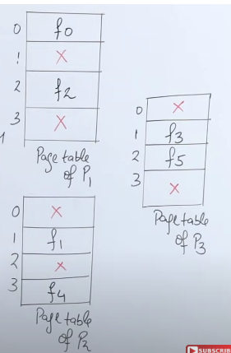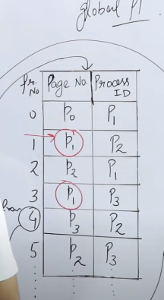

Page No 1 bohot saare hai ism Coz Different Processes m Page number 1 hain.

Linearly Search krna pdega Ex - Page number 2 Process 3 ka frame number 5 me bda hua hai

Dis – Searching time kum hua hai,

Adv - Memory zyada utilize ni kr ra lekin.

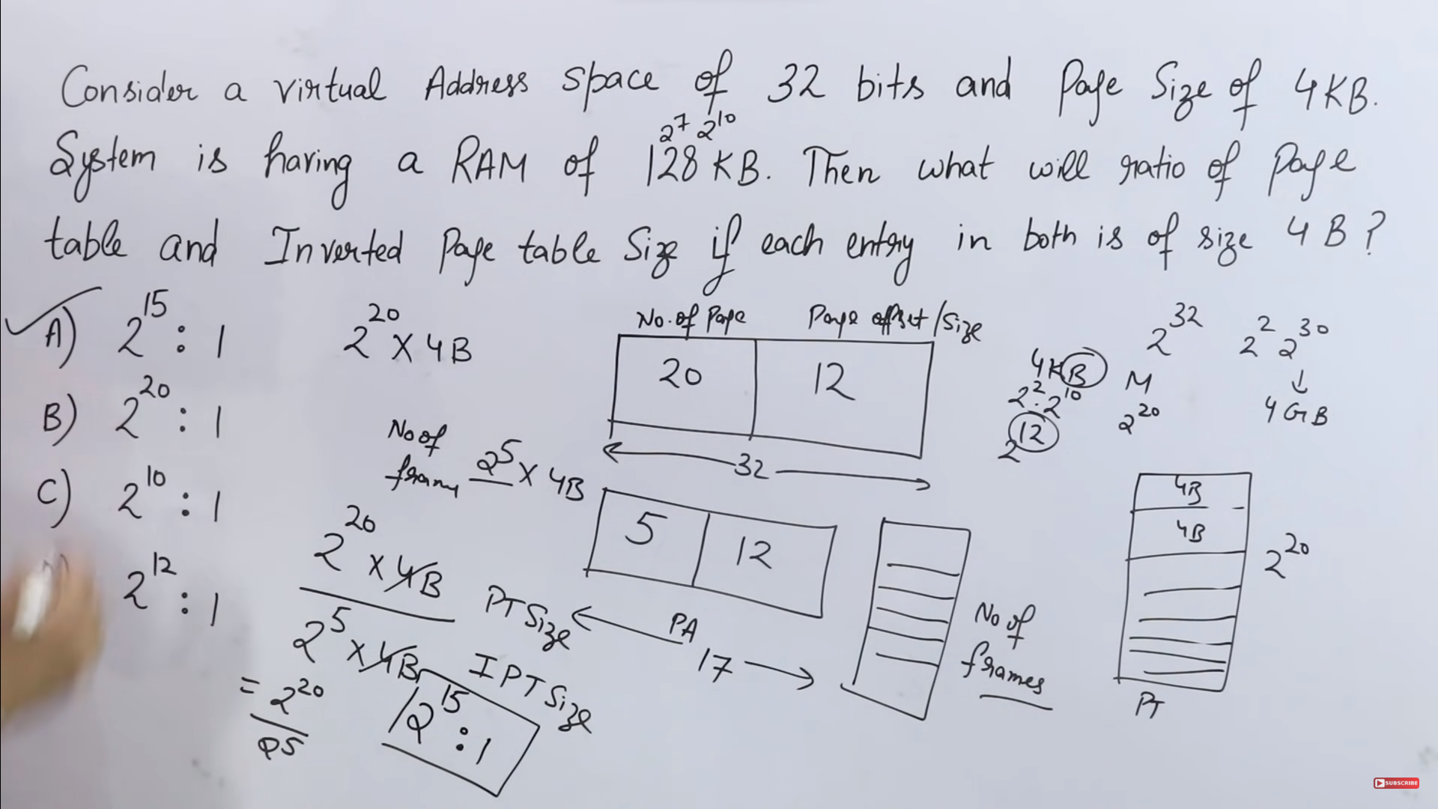

**Thrashing –** Bringing Max Processes in RAM (Degree of Multiprogramming)

Toh itne saare processes toh la ani skte toh harr process k 1 ya 2 Pagees ko le k aate hai andar, tb shuru m CPU utilization toh baadhiya hota hai ki Ek agr process beech m I/O k liye jana chahta hai toh baaki ajayenge execute hone. Pr ek time k baad (lambda here) kyunki poora process nii aaya hai sirf Part of process ayah ai toh PAGE FAULT hoga bohot saara. Toh hard disk se lane m CPU ko time jayega isko kehte hai **THRASHING.**

To avoid this

1. Main Memory increase kr do (Mushkil hai).
2. Long term Schedular - Iska kaam hota hai zyada se zyada Processes ko RAM k andar lana toh agr LTS agr thoda kum le k aayega Process toh Thrashing avoid hoskta hai.

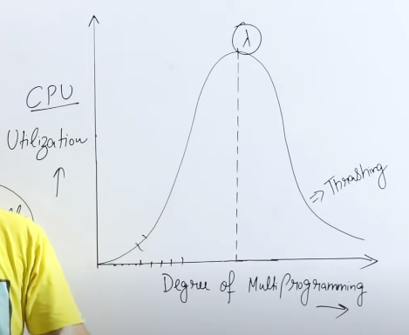

**Segmentation** – Processes ko variable size me divide krna hota hai.

Logical Address ko fir se idhr bhi Physical address m convert krna hoga.

Similar hai thoda sa Paging se, bs size variable hota hai ism.

Segment hamesha Related data ko ek segment m rkhta hai.

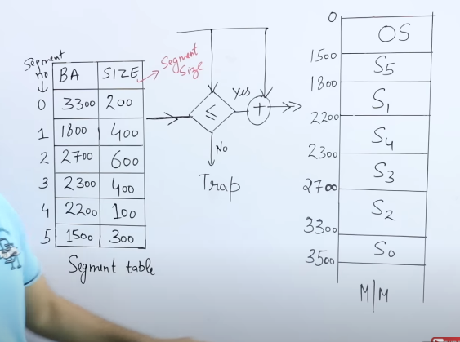

Agr S0(Segment Number check kr) ka pta krna hai kidhr hai wo Toh Base Address check kr(Jidhr se shuru hora hai wo segment) then size bta rah ai kidhr tk jar a hai wo.

So, S0 =3300-3500

Logical Address

MSB LSB

________|_______

Segment Segment

No. Size

S D

|  |  |
| --- | --- |
| 0001 | 10000 |

Agr ab S1 ko uthana hai tb

Segment table me 1800 value hai uski and size humko diya hai ki d=400

Ab dekhna ye pdega kitna part uthane bola hai CPU d<=size hona chahiye

Mtlb d=500 ni hoskta kyunki S1 ki value poori 400 hai.(agr 500 de deta toh trap ya error ajayega).

Then MM se utha lega S1

| **Feature** | **Segmentation** | **Paging** |
| --- | --- | --- |
| **Basic Concept** | Divides a program into logical segments (code, data, stack, etc). | Divides physical memory into fixed-sized blocks called pages. |
| **Unit of Division** | Segments (variable-sized logical units). | Pages (fixed-sized physical units). |
| **Size of Units** | Variable sizes for segments. | Fixed size for pages. |
| **Memory Allocation** | Each segment is allocated independently. | Allocation is done in fixed-sized pages. |
| **Internal Fragmentation** | Can lead to internal fragmentation if segments are not efficiently used. | Less internal fragmentation due to fixed-sized pages. |
| **Address Translation** | Requires both a segment and an offset within the segment for translation. | Requires a page number and an offset within the page for translation. |
| **Table Complexity** | Segment table is more complex, as it needs to manage base and limit information for each segment. | Page table is simpler, as it only needs to manage page numbers. |
| **Sharing and Protection** | Easier to implement sharing and protection at the segment level. | More complex to implement sharing and protection due to fixed-size pages. |
| **Handling Growing Processes** | Can handle growing processes more flexibly by dynamically allocating more space for segments. | May require dynamic page allocation mechanisms for growing processes. |
| **Example** | Intel x86 architecture uses segmentation. | Many modern systems, including x86 with PAE or AMD64, use paging. |

**Overlay -**is a method of putting large size Process in MM.

Partition kr do Process ka and us partition ko le k aai MM me jiski zaroorat pehle hai and Isko user krta hai (used in Embedded System). Dikkat idhr hoti hai ki agr 2 part m divide hua hai aur upr ka part laa re MM me nd pta chla upr k part ka koi code depend krta hai eeche k part pr toh dikkat hojayegi.

Overlay udhr use krte jahan MM ki size bohot kum hoti aur Processes ki size zyafa hoti.

**Virtual Memory –** Illusion create krta hai ye ki, Zyada memory hai apne pass.

Main Memory or Physicak Memory toh limited hai but Processes k size bohot zyada hote toh instead of ki poore Processes ko le k aaya hum Kuch pages ko Jinki zaroorat hai unko le aaye bs MM me and jb unka kaam hojaye tb Dusre Processes ko le aaye(Swap in/Roll in or Swap out/Roll out) jisko kehte hai Page Replacement.

Page Fault ka mtlb wo page hai ni Process k andar.

Effective Memory Access time =(Probability that there will be Page fault)(Page fault service time) + (1- Probability that there will be Page fault)(MM access time)

EMAT =P(PFST)+(1-P)(MMAT)

1-P means jb koi fault ni hai.

MMAT is in nanosecs.

PFST is in millisecs.

PFST means ki MM me hi nahi hai wo page usko SM memory se le k aao ab.

**LAS ka mtlb hota hai Logical Address Space jahan processes pde hote hian divided into pages.**

**Translation lookaside Buffer –** Processes k kuch pages ko TLB m rkh lo and agr wo page CPU ne manga aur TLB m hai toh jaldi mil jaayega aur ni mila toh use Page Table(PT) only. Fast hai TLB.

EMAT =Hit case(TLB+MM) +Miss case(TLB+PT+MM) if there is no page fault ki milega hi TLB se nit oh PT.

TLB ka time=PT =MM

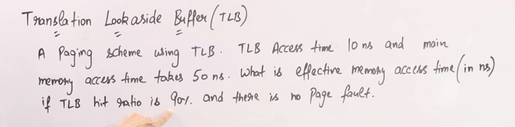

EMAT =Hit case(TLB+MM) +Miss case(TLB+PT+MM)

Miss Ratio = 1-Hit ratio (100%-Hit)

EMAT=90%*(10+50) + 10%*(10+50+50)

=0.9(60) + 0.1(110) = 65ns (page fault hota toh PFST bhi add krte)

**Page Replacement** – Saare Process ko le k ni aaskte toh imp pages ko le kr aate from different Processes MM me and jiska kaam hogya hai uss se replace kr do.

Virtual Memory ka Concept.

Algos –

1. **FIFO –** Jo frame pehle bhra toh usko khaali kr do

7 ki zaroorat hui toh usko daalo MM me thn 1 ki zaroorat hai wo hai ni MM me toh next unit time me 7 aayega neeche then 1 aayega. Then 0 ki zaroorat hui toh next unit time m 7 aayega 1 aayega 0 aayega. Then 2 aaya ab jagah ni hai tb FIFO k hisaab se 7 repace hoga and 1 and 0 same honge Fir agr 0 ki zaroorat wps hui toh 0 toh already present hai toh saare frames repeat honge. Then 3 aaya tb 1 replace hoga. 1 aaya wps lekin 1 agr hatt gya hai thaa pehle lekin hatt gya hai thoda der pehle toh bhi koi ni FIFO replace hoga.

Thoda upar neeche hogya hai statement lekin concept same hai.

Jb **frame** me **present ni hota** hai ek bhi **page** ya variable toh **Fault** hai and agr **present hai** toh **Hit** hota hai.

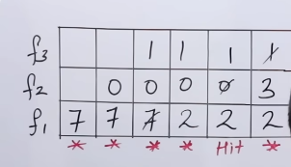 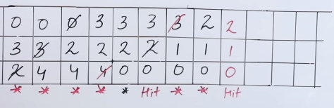

Page hit aaye 3

Page Fault aaye – 12

Hit ratio = 3/15*100

**Belady’s Anomaly in FIFO**

Using 3 frames -

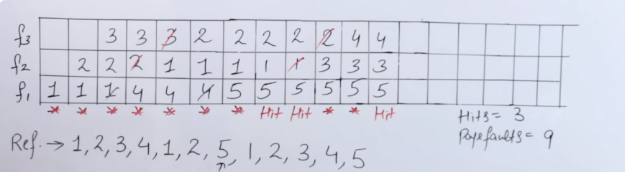

Using 4 frames now –

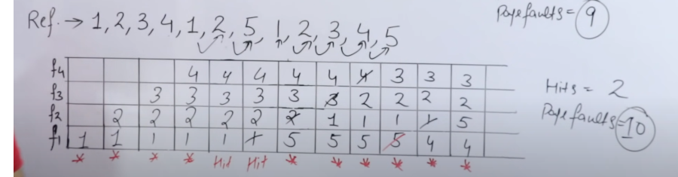

**Ek hi string ko alag alag Frames se kiya tb Hit and Miss Diff hoga, Ab number of hits kum hogya nd faults bdh gye with increase in number of frames. This is called Belady’s Anomly (Only happens in FIFO).**

1. **Optimal Page Replacement Algo –** Whenever Page Fault occurs we will replace the Page whose demand is the least in the future.

Pehle Fill kr lo jitne frames hai utne.

Reference String mo check kro jb frame fill hone k baad page fault agr aata hai then jiski last m imp hai usko replace kr do. First occurrence check krna page fault k baad jaise yahan 2 aagya then 1 aagya 0 aagya 7 unk baad aaya(first occurence). Then 7 replace kr dega 3 se. and agr usk baad kbhi replace krne ka aaya aur koi page hai hi ni list me toh usko kr dena replace.

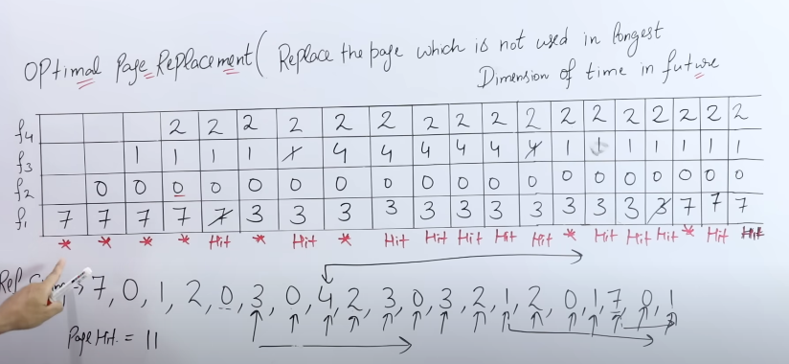

Page hit = 12 Page faults = 8

**Least Recently Used Algo (LRU) -** Usko replace kro jo ki least recently (last )use hua tha past me. Slow hai FIFO se coz search algo use ho ra to check the past.

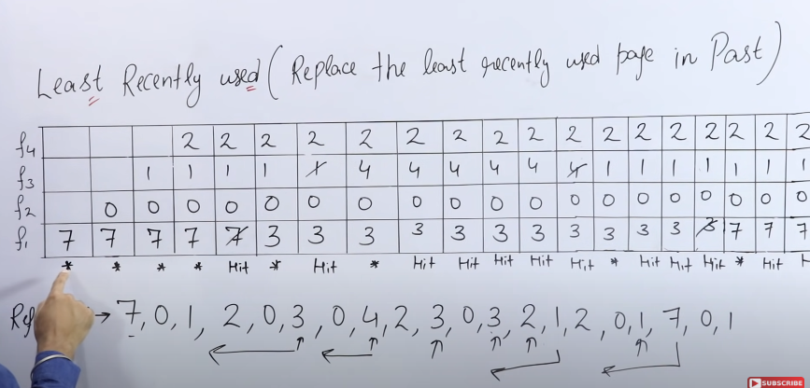

Page Faults =7 Page Hit =12

**Most Recently used algo –** usko replace kro jo ki recently use hua tha past m.

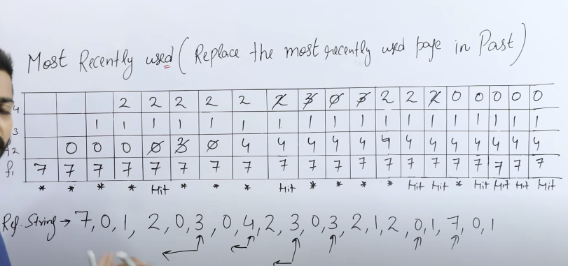

Page Fault = 12 Page Hit=8

**Disk Architecture –**

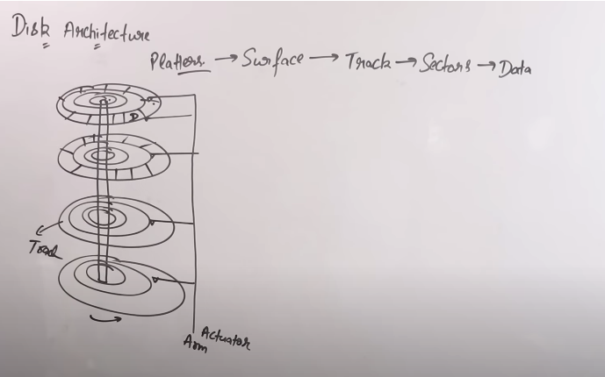

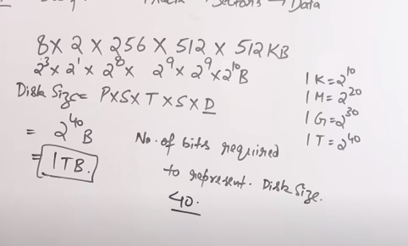

Disc Access Time – ST+RT+TT + (Controller Time + queue Time.)

Bracket wala optional hai

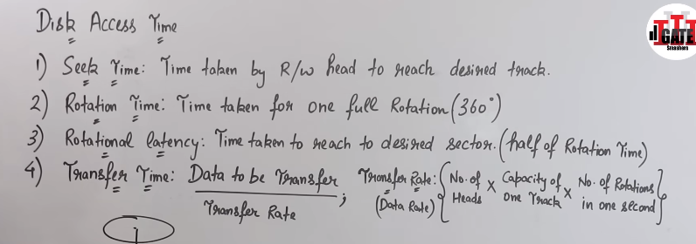

Disk Scheduling Algo –

1. FCFS – **Adv is** that there wont be any starvation mtlb ki koii request ko zyada wait ni krna pdega, jis sequence m gye hai saare requests usi sequence m wps ayene. **Dis is** Seek time ki value zyada hoti hai

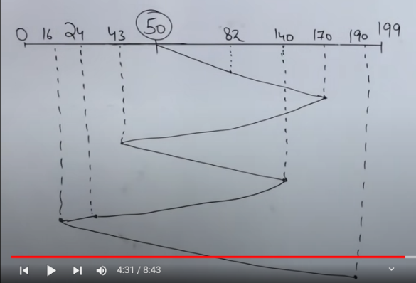

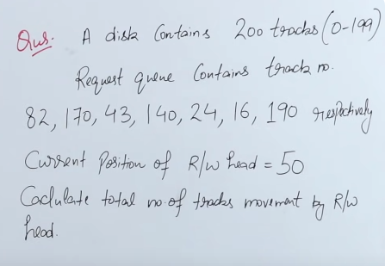

82-50 (first request) + 170-82 + 170-43 + 140-43 + 140-24 +24-16 + 190-16 = 642

Or Direction chnge tk chlna hai

170-50 + 170-43 + 140-43 + 140-16 + 190-16 = 642

**SSTF – Shortest Seek time First –** Jo value nearest hai uski taraf jana hai.

Response time fast hai, Optimal Result deta hai, Seek time kum hai.

Dis is Starvation, overhead bdh jata hai (search krna pd ra na harr baar who is closest)

50 to 43 jayega 43->24->16->82->140->170->190

Direction chnge tk chlna hai

50-16 + 190-16 = 208

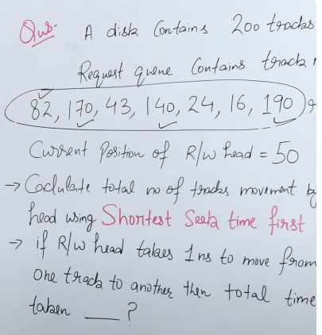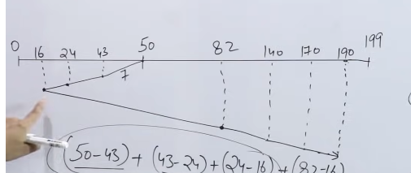

**SCAN algorithm** – Jis direction m bola hai us direction m bola hai. Also called Elevator Algo.

Larger value m jana bola hai.

50->82->140->170->190->199(199 given ni hai lekin jana hai)

Idhr khtm hui larger value now smaller values

190->43->24->16 lekin 0 m ni jana hai.

Jis direction m bola hai usk last point tk jana hai lekin dusre direction k ni.

190 tk bola hai lekin gye 199 tk

Agr 16 taraf jana shuru kiye aur beech m 195 aagya toh ni jana hai 16 taraf jaao pehle.

Last point tk isliye jar a kyunki Agr run time m request aagyi agr toh.

190-50 + 190-16 = 332

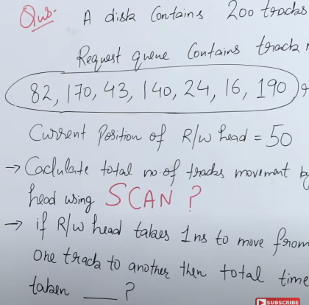 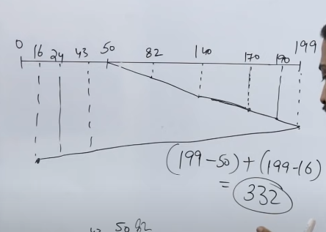

**Look Algo –** like Scan only and the que will tell in which direction to go

Large Direction here

Look bs largest given value tk jaayega lekin last tk ni jayega

50->82->140->170->190->43->24->16 (190 tk jana hai 199 tk NAHI)

190-50 + 190-16 =314 (1ns lgta hai to go from one track to another so to go to 314 Tracks it will take 314*1 = 314ns)

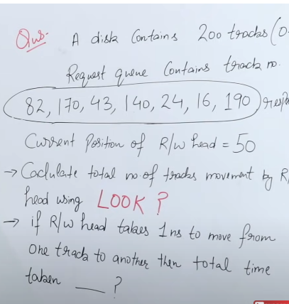 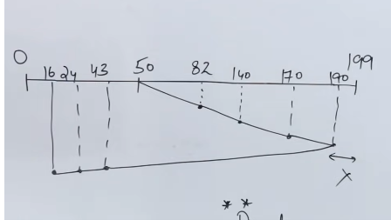

**C-Scan Algo –** Ism bhi last Point tk jana hai after the larger value(agr larger value k side jane bola hai tb) thn siddha opposite side (0 size jana hai idhr) jana hai then baaki k values cover krne hain.

50-82-140-170-190-199-0-16-24-43

Movement = 199-50 + 199-0 + 43-0 = 391

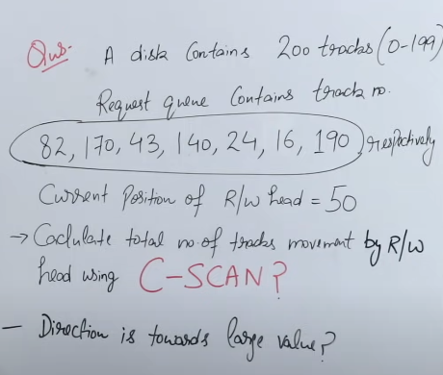 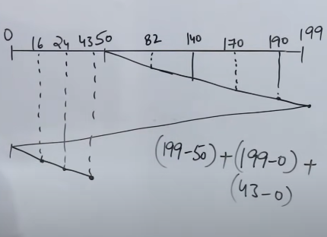

**C-Look Algo –** Large value jana hai, largest value tk jaa then smallest tk wps ja thn baaki ka cover kr.

50-82-140-170-190-0-16-24-43

Total Movement = 50-190 + 190-16 + 43-16 = 341

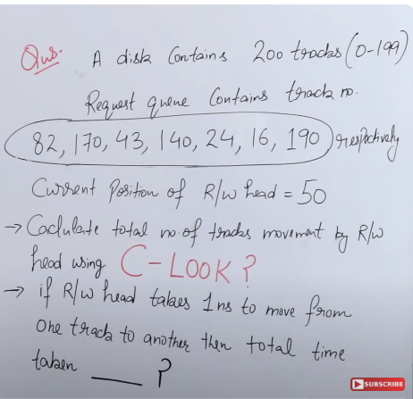 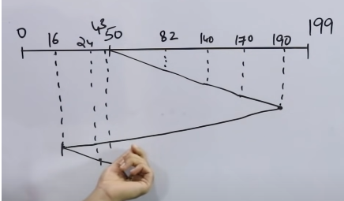

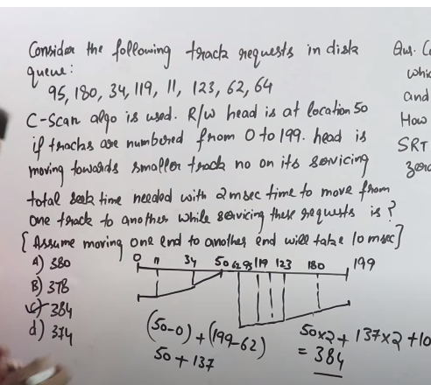50=>0

199=>62

2ms diya hai movement ka

50*2+137*2

0 to 199 jata hai 10ms me

50*2+137*2+10=384

**File System in OS** – It tells that how a data will be stored and fetched in a system. The main role is it store the mapping in which the data is stored in Hard disk. The data is divided into blocks logically and are stored in sectors in disk.

File F1 ko File system divide krta hai blocks me then Hard disk m sectors hote hai jo ki physical blocks hai (wo platter surface wala diagram) now in files k blocks ko wo sectors m daalega, isko kehte hai Allocation.

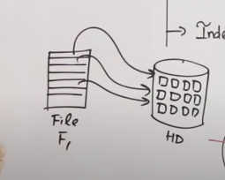Adv – Efficient Disk Utilization, Access Faster.

Allocation methods –

1. Contiguous – Line se baithenge shuru kidhr bhi kro F1 baitha 1st p toh 2nd s sb baithenge agr baitha 11th p toh 12th se sb baithenge.
2. Non- Contiguous - Linked List, indexed Allocation.

**Contiguous Allocation – Sequentially Rakha jata hai and Direclty utha skte hai** (Agr 9th Block pr jana hai toh bs us file ki starting pakad lo ex-6 and wahan se chle jaao).

Length ka mtlb kitne blocks le ra

A shuru hua 0 se 3 blocks liya

B shuru hua 6 se 5 blocks liya

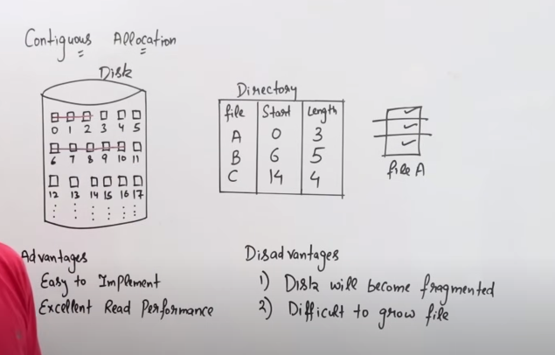

Difficult to grow file ka mtlb – ki jitne block assigned the pehle jb size badhi tb agr jagah khali hai toh daal skte lekin agr next block bhra hua hai toh ni kr skte.

**Linked List Allocation** – non contiguous hota hai agr File ka ek part block 1 m hai toh baaki k randomly honge kisi bhi blocks me and pehla wala dusre block ko point kr ra hoga and last block -1 ko point krega.

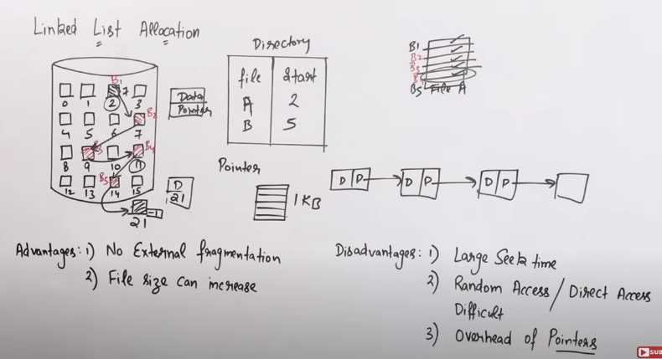

Pointers bhi kuch space lenge na Blocks me toh overdead hojayega.

**Indexed Allocation –** ek block m baaki saare Blocks k indexes pade hai.

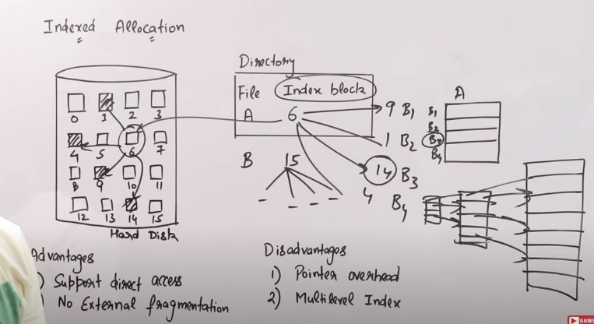

Hit ratio(TLB m khjne ka time+MM se access time) +

PT se milne ka time(TLB m khoje lekin ni mila + MM m khoje +Hit hogya toh ab uska time)Page fault occur ni hua +

Page fault hua((tlb me khoje ni mila+PT m ni mila+Disk se lane ka time)Dirtypage ni hai wala +

Dirty page ko nikal k SM m dalne wala(TLB +PT +Disk m ni mila + Disk s naya page lana))

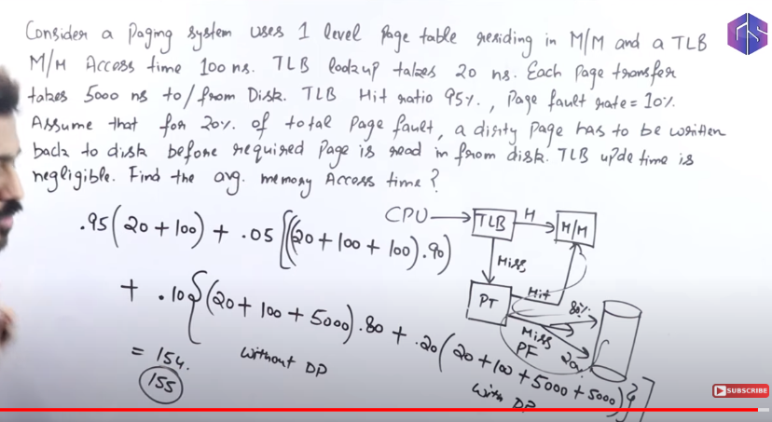

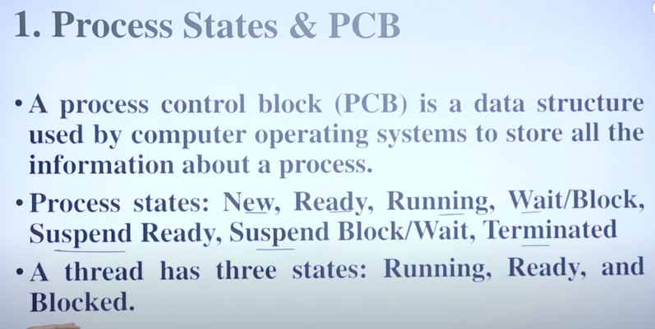

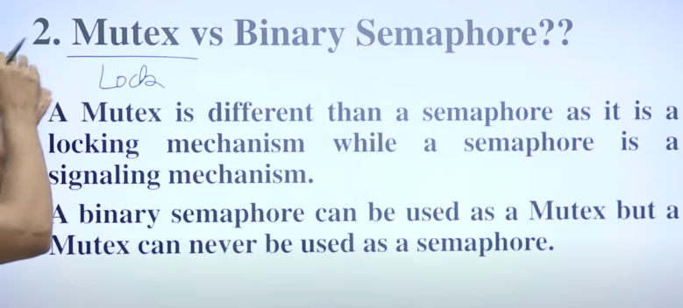

Mutex me agr gana sunn re toh call ni aaskta, Semahor m song ruk jata call aane pr.

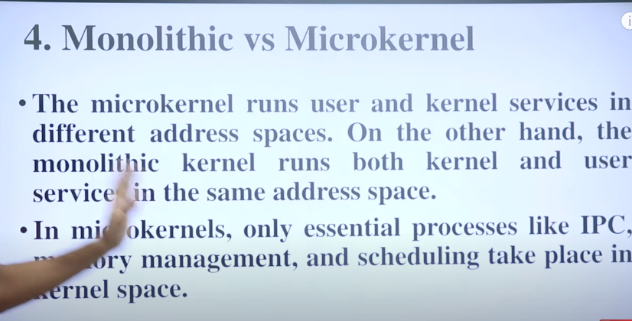

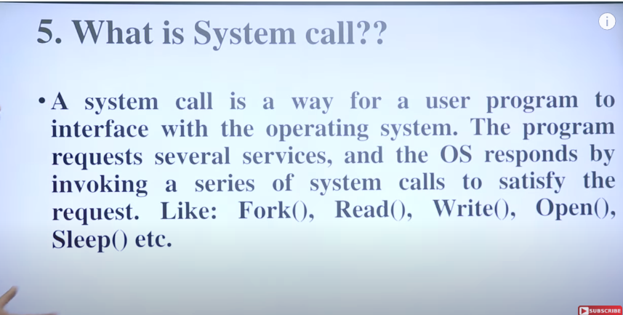

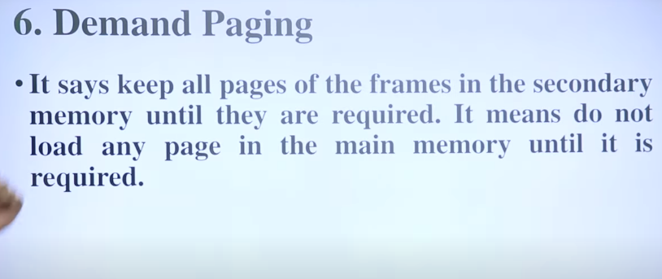

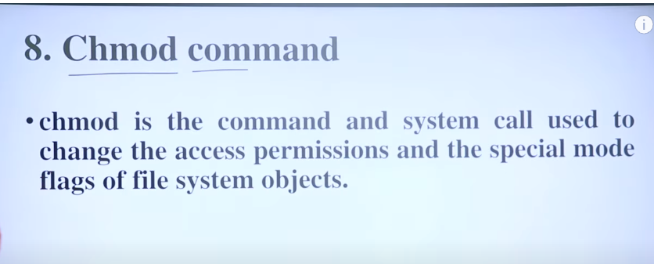

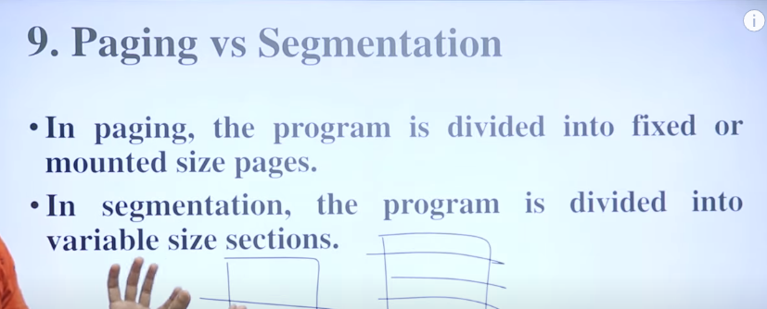

Seg kehta hai ki particular func ko alag kro same ko saath m rkho, page bs divide kro.

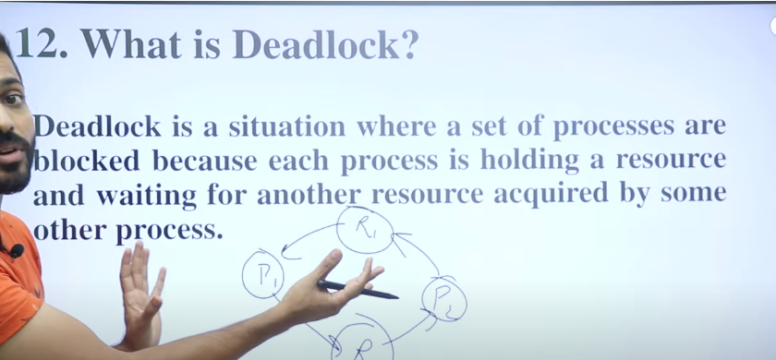

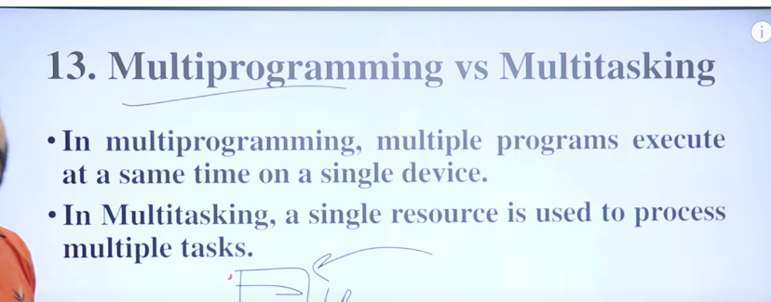

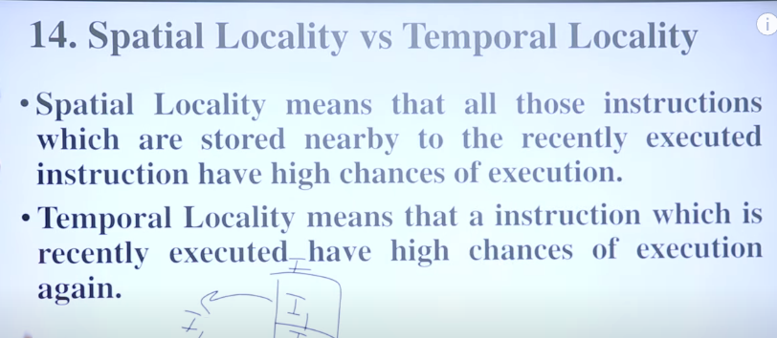

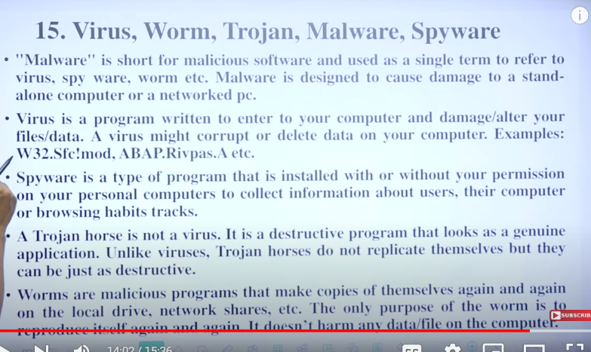

**Linker and Loader –** File k execution m kaam aate hai.

HHL – User likhta hai high level language me lihta hai

Compiler – compile krta hai assembly language me.

Assembler – Assembly file ko object file m convert krega.

Linker – Multiple Object files ko link krega ek saath and executable file m convert krega.

Loader – Load krega Memory me

Memory k baad CPU execute krega and Output dega

Object file m ye sb hota hai

